Project Design Phase
Solution Architecture

Date | 08/02/2026
Team ID | LTVIP2026TMIDS83275
Project Name | Deep Learning Fundus Image Analysis for Early Detection of Diabetic Retinopathy
Maximum Marks | 4 Marks

Solution Architecture:

1. Architecture Overview
The proposed system follows a Three-Tier Client–Server Architecture consisting of:
- Presentation Layer (User Interface)
- Application Layer (Backend Processing)
- Model Layer (Deep Learning Inference Engine)
The system is designed to automate diabetic retinopathy detection using a trained Convolutional Neural Network (CNN) model integrated with a web-based application.

2. High-Level Architecture Flow
User
↓
Web Interface (HTML/CSS)
↓
Flask Backend Server
↓
Image Preprocessing Module
↓
Deep Learning CNN Model
↓
Prediction Output
↓
Result Display on UI

3. Layer-wise Architecture Description

🔹 3.1 Presentation Layer (Front-End)
Purpose:
Handles user interaction.
Components:
- Web interface for image upload
- Result display section
- Severity classification output
Technologies Used:
- HTML
- CSS
- JavaScript (optional)
- Bootstrap (optional)
Function:
- Accept retinal fundus image (.jpg/.png)
- Send image to backend for processing
- Display prediction result

🔹 3.2 Application Layer (Backend Logic)
Purpose:
Controls business logic and communication between UI and model.
Components:
- Flask Server
- Image Validation
- Image Preprocessing Module
- Model Loader
Technologies Used:
- Python
- Flask
- NumPy
- OpenCV / PIL
Functions:
- Receives uploaded image
- Resizes image (e.g., 224x224)
- Normalizes pixel values
- Converts image to tensor format
- Sends processed image to CNN model
- Receives prediction
- Returns result to UI

🔹 3.3 Model Layer (Deep Learning Engine)
Purpose:
Performs classification of diabetic retinopathy severity.
Model Type:
- Convolutional Neural Network (CNN)
Technologies Used:
- TensorFlow
- Keras
Model Operations:
- Feature extraction via convolution layers
- Pooling layers for dimensionality reduction
- Fully connected layers
- Softmax output layer for classification
Output Classes Example:
- No DR
- Mild
- Moderate
- Severe
- Proliferative DR

4. Data Flow Description
- User uploads fundus image.
- Image stored temporarily on server.
- Image preprocessing applied.
- Processed image fed to trained CNN model.
- Model predicts severity class.
- Result displayed to user.

5. Deployment Architecture
🔹 Local Deployment
- Python Virtual Environment
- Flask Development Server
- Local CPU execution

🔹 Cloud Deployment (Optional)
- Cloud Platform (Railway / AWS / Azure)
- Gunicorn WSGI Server
- Containerized Deployment (Docker – optional)

6. Architecture Characteristics
- Modular design
- Model separated from UI
- Easy retraining capability
- Stateless inference
- Scalable cloud-compatible structure

7. Security Considerations
- Secure file upload validation
- Limited file type acceptance
- No permanent storage of patient images
- HTTPS-based deployment (for cloud)

Solution Architecture Diagram
Figure 1: Architecture and Data Flow Diagram

User
↓
Web Interface (Upload Image)
↓
Flask Backend
↓
Image Preprocessing
↓
CNN Model (.h5)
↓
Prediction Output
↓
Result Display on UI

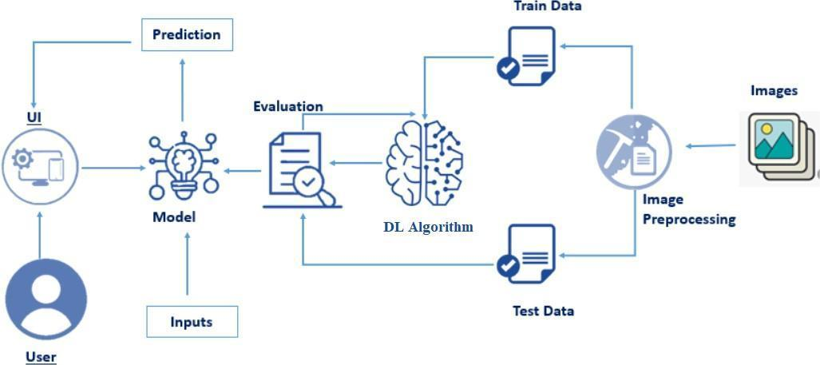
Flow:
Fundus Image Dataset → Preprocessing → Train/Test Split → CNN Model Training → Evaluation → Model Saving (.h5) → Web Integration → Prediction → User
Training Phase Flow:
Dataset → Preprocessing → Train/Test Split → CNN Training → Evaluation → Save Model

